BUBBLE SORT

- Bubble sort is a simple and well-known sorting algorithm.
- Given a list , we iterate through the items, swapping them if they are out of order.
- Bubble sort belongs to O(n²) sorting algorithms, which makes it quite inefficient for sorting large data volumes.

PSEUDOCODE

BubbleSort( int a[], int n)
Begin
for i = 1 to n-1
sorted = true
for j = 0 to n-1-i
if a[j] > a[j+1]
temp = a[j]
a[j] = a[j+1]
a[j+1] = temp
sorted = false
end for
if sorted
break from i loop
end for
End

ALGORITHM

Bubble sort uses a loop (inside j loop) to travel through an array comparing adjacent
values as it moves along. If an array element a[j] is greater than the element
immediately to its right a[j+1], it swaps them. The first time around, this process will
move or bubble the largest value to the end of the array. So for instance

5 3 1 9 8 2 4 7
will end up as
3 1 5 8 2 4 7 9

This process is repeated, on the second iteration, the second largest value will be
moved to the second last array position and so on. In all, the bubble process (inside j loop) is repeated n-1 times for an array of size n.

EXAMPLE

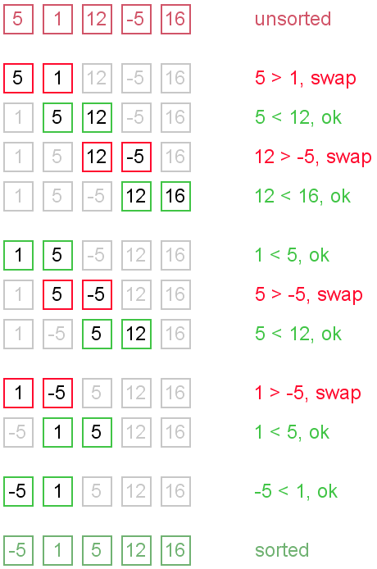

INSERTION SORT
- Insertion sort belongs to the O (n²) sorting algorithms.
- It is used for sorting small arrays of data. Insertion sort algorithm resembles selection sort.
- Array is imaginary divided into two parts - sorted one and unsorted one.
- At the beginning, sorted part contains first element of the array and unsorted one contains the rest.
- At every step, algorithm takes first element in the unsorted part and inserts it to the right place of the sorted one.
- When unsorted part becomes empty, algorithm stops.

PSEUDOCODE
For I = 1 to N-1
J = I
Do while (J > 0) and (A(J) < A(J - 1)
Temp = A(J)
A(J) = A(J - 1)
A(J - 1) = Temp
J = J - 1
End-Do
End-For

EXAMPLE
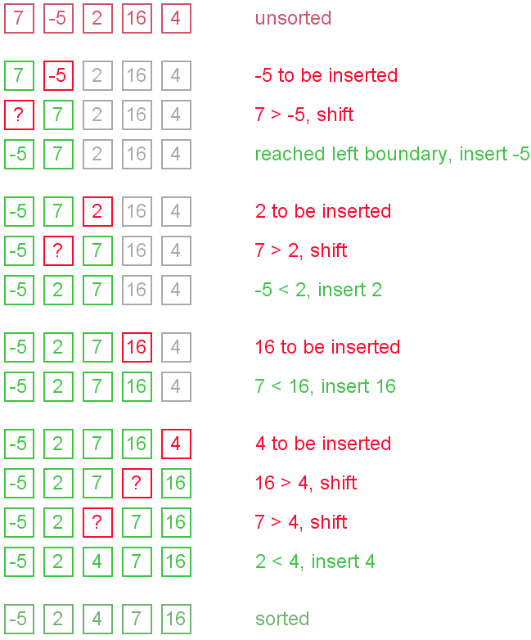

SELECTION SORT

- Selection sort is one of the O (n²) sorting algorithms, which makes it quite inefficient for sorting large data volumes.
- Selection sort is notable for its programming simplicity and it can over perform other sorts in certain situations.
- Array is divided into two parts - sorted one and unsorted one.
- At the beginning, sorted part is empty, while unsorted one contains whole array.
- At every step, algorithm finds minimal element in the unsorted part and adds it to the end of the sorted one. When unsorted part becomes empty, algorithm stops.
- When algorithm sorts an array, it swaps first element of unsorted part with minimal element and then it is included to the sorted part.
- This implementation of selection sort in not stable.
PSEUDOCODE
For I = 0 to N-1 do:
Smallsub = I
For J = I + 1 to N-1 do:
If A(J) < A(Smallsub)
Smallsub = J
End-If
End-For
Temp = A(I)
A(I) = A(Smallsub)
A(Smallsub) = Temp
End-For
EXAMPLE
5, 1, 12, -5, 16, 2, 12, 14
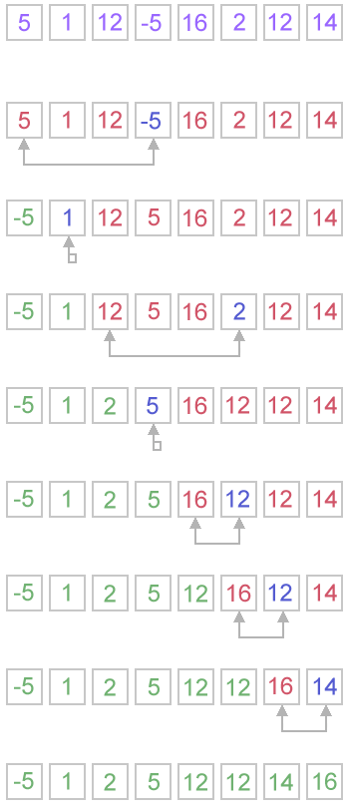

QUICKSORT
- Quicksort is a fast sorting algorithm, which is used not only for educational purposes, but widely applied in practice.
- On the average, it has O(n log n) complexity, making quicksort suitable for sorting big data volumes.

Algorithm
The divide-and-conquer strategy is used in quicksort. Below the recursion step is described:
- Choose a pivot value. We take the value of the middle element as pivot value, but it can be any value, which is in range of sorted values, even if it doesn't present in the array.
- Partition. Rearrange elements in such a way, that all elements which are lesser than the pivot go to the left part of the array and all elements greater than the pivot, go to the right part of the array. Values equal to the pivot can stay in any part of the array. Notice, that array may be divided in non-equal parts.
- Sort both parts. Apply quicksort algorithm recursively to the left and the right parts.

PARTITION ALGORITHM IN DETAIL
There are two indices i and j and at the very beginning of the partition algorithm i points to the first element in the array and j points to the last one. Then algorithm moves i forward, until an element with value greater or equal to the pivot is found. Index j is moved backward, until an element with value lesser or equal to the pivot is found. If i ≤ j then they are swapped and i steps to the next position (i + 1), j steps to the previous one (j - 1). Algorithm stops, when i becomes greater than j.
After partition, all values before i-th element are less or equal than the pivot and all values after j-th element are greater or equal to the pivot.
EXAMPLE

Sort {1, 12, 5, 26, 7, 14, 3, 7, 2} using quicksort.
quicksort(int x[10],int first,int last)
{
int pivot,j,temp,i;
if(first<last){
pivot=first;
i=first;
j=last;
while(i<j){
while(x[i]<=x[pivot]&&i<last)
i++;
while(x[j]>x[pivot])
j--;
if(i<j){
temp=x[i];
x[i]=x[j];
x[j]=temp;
}
}
temp=x[pivot];
x[pivot]=x[j];
x[j]=temp;
quicksort(x,first,j-1);
quicksort(x,j+1,last);
}
}

Merge Sort
Merge Sort is one of the most popular sorting algorithms that is based on the principle of Divide and Conquer Algorithm.
Here, a problem is divided into multiple sub-problems. Each sub-problem is solved individually. Finally, sub-problems are combined to form the final solution.
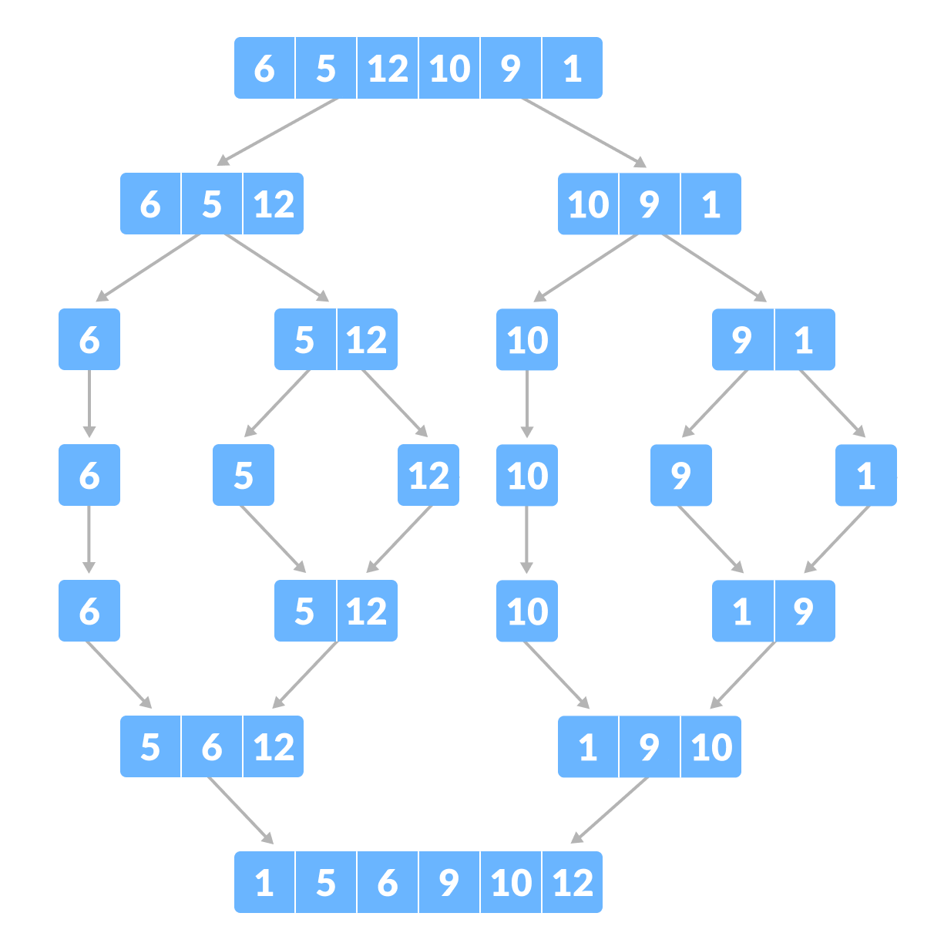Merge Sort example

Divide and Conquer Strategy
Using the Divide and Conquer technique, we divide a problem into subproblems. When the solution to each subproblem is ready, we 'combine' the results from the subproblems to solve the main problem.
Suppose we had to sort an array A. A subproblem would be to sort a sub-section of this array starting at index p and ending at index r, denoted as A[p..r].
Divide
If q is the half-way point between p and r, then we can split the subarray A[p..r] into two arrays A[p..q] and A[q+1, r].
Conquer
In the conquer step, we try to sort both the subarrays A[p..q] and A[q+1, r]. If we haven't yet reached the base case, we again divide both these subarrays and try to sort them.
Combine
When the conquer step reaches the base step and we get two sorted subarrays A[p..q] and A[q+1, r] for array A[p..r], we combine the results by creating a sorted array A[p..r] from two sorted subarrays A[p..q] and A[q+1, r].

void partition(int list[],int low,int high)
{
int mid;
if(low < high)
{
mid = (low + high) / 2;
partition(list, low, mid);
partition(list, mid + 1, high);
mergeSort(list, low, mid, high);
}
}

void mergeSort(int list[],int low,int mid,int high)
{
int i, hi, k, lo, temp[50];

lo = low;
i = low;
hi = mid + 1;
while ((lo <= mid) && (hi <= high))
{
if (list[lo] <= list[hi])
{
temp[i] = list[lo];
lo++;
}
else
{
temp[i] = list[hi];
hi++;
}
i++;
}
if (lo > mid)
{
for (k = hi; k <= high; k++)
{
temp[i] = list[k];
i++;
}
}
else
{
for (k = lo; k <= mid; k++)
{
temp[i] = list[k];
i++;
}
}

for (k = low; k <= high; k++)
{
list[k] = temp[k];
}
}

COUNTING SORT

Counting sort is a sorting technique based on keys between a specific range. It works by counting the number of objects having distinct key values (kind of hashing). Then doing some arithmetic to calculate the position of each object in the output sequence.
Let us understand it with the help of an example.
For simplicity, consider the data in the range 0 to 9.
Input data: 1, 4, 1, 2, 7, 5, 2
1) Take a count array to store the count of each unique object.
Index: 0 1 2 3 4 5 6 7 8 9
Count: 0 2 2 0 1 1 0 1 0 0

2) Modify the count array such that each element at each index
stores the sum of previous counts.
Index: 0 1 2 3 4 5 6 7 8 9
Count: 0 2 4 4 5 6 6 7 7 7

The modified count array indicates the position of each object in
the output sequence.

3) Output each object from the input sequence followed by
decreasing its count by 1.
Process the input data: 1, 4, 1, 2, 7, 5, 2. Position of 1 is 2.
Put data 1 at index 2 in output. Decrease count by 1 to place
next data 1 at an index 1 smaller than this index.

void countingSort(int array[], int size) {
int output[10];

int max = array[0];
for (int i = 1; i < size; i++) {
if (array[i] > max)
max = array[i];
}

int count[10];

for (int i = 0; i <= max; ++i) {
count[i] = 0;
}

for (int i = 0; i < size; i++) {
count[array[i]]++;
}

for (int i = 1; i <= max; i++) {
count[i] += count[i - 1];
}

for (int i = size - 1; i >= 0; i--) {
output[count[array[i]] - 1] = array[i];
count[array[i]]--;
}

for (int i = 0; i < size; i++) {
array[i] = output[i];
}
}

